# Computer Vision Hw6 Report

* Discription
  + Yokoi Connectivity Number
* Algorithm
  + 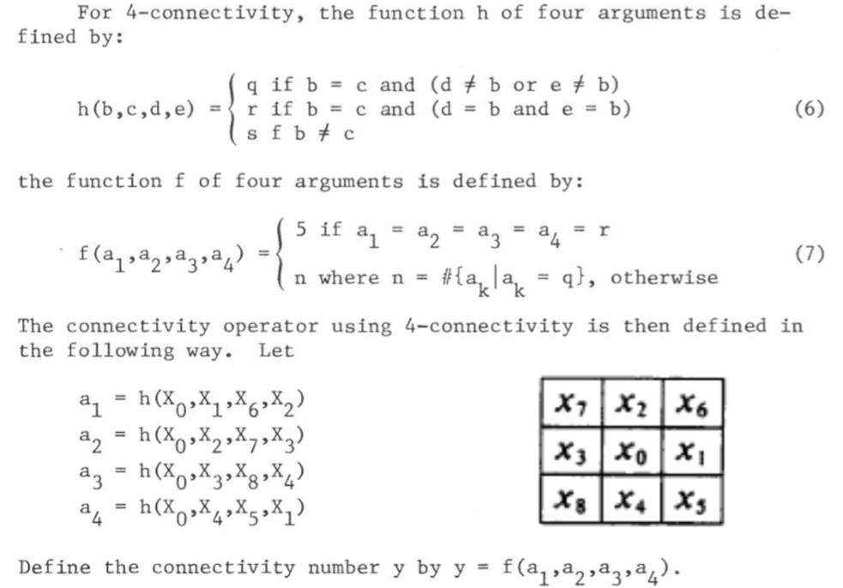
* Parameters (if any)
  + no
* Principal Code Fragment

Main (file – /src/hw6/ DemoYokoiConnectivityNumber.java)

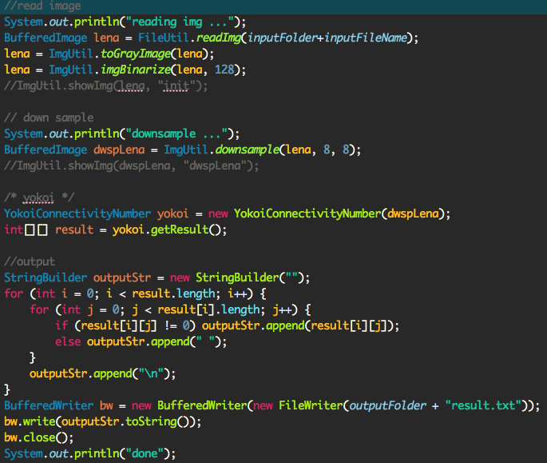

Yokoi Connectivity Number

(file – /src/cv1.util.cv /YokoiConnectivityNumber.java)

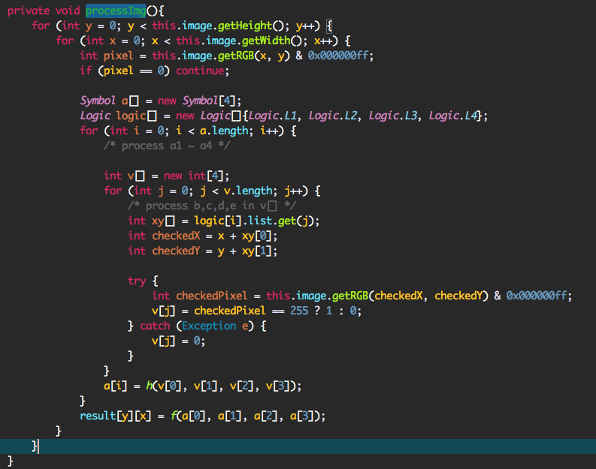

* Result Image

